AFFIDAVIT BY Renjith Raveendran Nair

Re: Chandra Moul.i Nallakukkala

I, Renjith Raveendrnn Nair, hereby depose and say upon oath as follows:

- That I, Renjith Ravcendran Nair, was born on 11/20/1982 in the town/city of Kacluthuruthy, Kera1a in India,
- My full and complete address is 20225 Bothell-Everett Hwy4t 1734, Bothell, WA 98012,
- That Tam acq1iainted with Chandra Mouli Nallakukkala. I was his co-worker
- During the period 04/13/2011 and until 02/07/2014, I was employed with Xavicnt information systems Inc,
5, That I have direct personal knowledge of the event and circumstances concerning the employment of Chandra Mouli Nallakukkala with Xavient information systems lnc.
- That from 04/13/2011 and until 02/07/2014 Mr. Chandra Mouli Nallakukkala worked as a Sr.SAP Consultant, to my knowledge no less than 40 Hours per week.
- I certify that as a Sr.SAP Consultant, Mr. Chandra Mou.ti Nallakukkala to my knowledge performed the following duties;

COMPLETE AND DETAILED JOB DESCRIPTION

Environment Worked: SAP BW 7.3, SAP BW/PDM 7.3, SAP ECC 6.0, SAP PI, TIBCO & POS

  - Developed all Administrative Work Bench objects in BW, and transport it across landscapes
0 Accommodating the Point of sales and Assets data in DSO'S yearly wise and Cubes in quarterly wise to improve query and load performance.
  - Done the Unit testing n development system.
  - Co-ordinate the transportation of objects across the landscape.
- Configured the sales item types, Tax types in sap PDM system
  - Loaded the master data for sales item type and tax types,
  - Created info objects, Info packages, transformation and Data Targets (DSO, Cubes),
  - Done the Unit testing for all interfaces in BW comparing with soui-ce.

Pre-upgrade tasks

- To prevent loss of Function group fo1· web service data source during the upgrade.
  - Make sure no open conversions exist.

e Check Bad requests in DSO
  - Clear the delta queues by running Info packages.
° Check Inactive objects before upgrade
Post Upgrade Tasks

  - Check Data Source Issues after Upgrades from NW 7.0
- Check the Multi Provider Design using program after upgrade
- Updating the Where-lJsed List in the ABAP Workbench using program
° Compm·e Inactive obje<.;tS before and after upgrade

I declare under penalty of pe1jtiry, that the foregoing is a true and correct statement.
aL,.:----' •
Rcnjith Raveendran Nair
20225 Bothell Everett Hwy# 1734
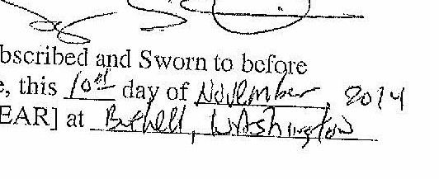
Bothell, WA 98012

s
>.'l,'N1+,'A A'J..'A'h'A"A'AWNA0nA1AWA1A'A'/.!RA'l.'A'A"AWA'A'lt'A'/l.'A'AWAWA.'h';.
iSAYI\iOR
I(IMI
I Notary Pu Hc j
State of Washmgton
Commission li'.XJ>ii'cs Octobel' 31, 2015§.
t ..
'1,'f,v,v.v.v.v,'lf.V,V.,V.YN,W-1,Y,l/,\/N.V.V.v.v.v.v.v.v,YN.Y,V.V,11.V,VN VY,.V."l,V'Jt

